General Education

\*the rest of the IEP from a different student\*

Updated with information from an informal meeting with (general ed), 4th grade Dual Language Teacher: "One of student strengths is her reading. Her fluency has improved. Read180 has helped a lot with her fluency and her writing has also improved. Faith's mindset has grown since the beginning of the school year. She is doing and completing challenging work- especially in Spanish, which isn't her first language, she is working through it. Faith has improved with writing, she's grown a lot but not where we want to be. I would love to her to start reading at home. Re-reading. I would love to see Faith reflecting on her reading, "Did I read this correctly?" "Does this make sense to me" Continue all testing accommodations."  
Reading & Math Data  
STAR Reading English  
Fall: 113  
Spring: 463 (instructional level 3.9)   
-->350 points of growth!

Students complex emotional, behavioral, executive functioning, and academic skill needs adversely impact Students ability to fully access general education curriculum and fully participate in the general education setting. Students l will participate with his general education peers during general education classes, lunch, recess, art, music, P.E., library, assemblies, science, field trips, etc.

When Students is in general education environments (main classroom, specialists, recess, etc), Students needs preferential seating away from distractions and within close proximity to the teacher, modified length of assignments or assignments broken into chunks, and extended time on assignments. Additionally, Students benefits from previewing or pre-teaching of general education concepts. When (student) l has received pre-teaching, he is more likely to complete work in the general education setting.

Due to Students unique behavior needs, the following supports are essential in providing Students with an appropriate, enriching, and supportive educational environment that allows for him to access the general education classroom and curriculum: check-in/check-outs, positive if/then statements, positive reinforcement, use of timer, breaks, specially designed instruction for handling social and academic situations, and a token economy system.

Adverse Impact Statement

Social-Emotional & Behavior

Emotional Regulation: Voice and Volume Control

Strength: Student has grown a lot in the area of emotional regulation. For example, when faced with a situation that causes him anger or frustration, he is able to express what is causing him to feel this way. Another strength is (name) understanding of being an up stander in situations where his friends are getting bullied.

IEP goal: Social Skills: Emotional Regulation: when given specialized instruction in emotional regulation (name) will use an age-appropriate voice and volume level in class improving the ability to self-regulate from a current level of 30% of the time to at least 80% of the time as measured by monthly teacher data.

IEP goal progress: Based on data collected for progress reports on January 25th, Teacher rated (name) at a “1” which she compared to his point behavior rating system that I created, which correlates to him using appropriate voice and volume level 40-70% of the time. In the resource room, (name) uses an appropriate voice and volume level 90% of the time. Based off observation and data, I suggest (name) has successfully met his goal of regulating his voice and volume in the classroom setting.

Area of concern: While (name) has made great gains in complying with requests from adults and peers, regulating and expressing his emotions, and his self-control, he struggles to maintain the personal space of other students. For example, it was observed that (name) will invade other’s space during class activities, worktime, and discussions, attempting to gain attention and get them off-task. The behavior was not describe as bullying, but more of an attempt to gain attention from peers or escape academic work himself. These behaviors are viewed from peers as distracting and annoying and disrupt the learning environment of others and himself. These behaviors are persistent and effect almost the entire class.

IEP goal recommendation: I recommend focusing his specially designed instruction around maintaining personal space, seeking appropriate attention from peers, complying with requests, developing meaningful friendships, and collaborating with other peers in an educational setting. Rubric baseline: 1

Location of services: In order to best meet (student) behavioral and academic needs, 100 of his social skill minutes will be served in the special education setting and 20 minutes will be received in the general education setting to promote generalization of skill development and maintenance.

(student) qualifies for specially designed instruction in the academic areas of mathematical problem solving, reading comprehension, and writing. Please see the sections below for additional information.

Math- Problem Solving  
Strength: (student) has indicated that his favorite subject is math and he loves working on math for fun. (student) has strong math computation skills; specifically in multiplication, addition, and subtraction. He is able to apply multiple forms of computation to reach the correct answer and he has strong mental math.

Current IEP goal: Math: Problem Solving: when given a 3rd grade math problem solving probe (student) will apply the concepts and procedures of mathematics to solve math problems improving the ability to use algebraic concepts, fractions and ratios, word problem solving strategies, and calculate area and perimeter from a current level of 4 corrects to at least 20 corrects as measured by monthly teacher data.

IEP goal progress: On (student) last 3rd grade problem solving probe, he had 19 corrects- 1 correct away from meeting his IEP goal. When analyzing the probe, many of the skills that were being measured are not aligned to common core standards and do not represent what he is learning in the general education or resource room setting. When focusing on data from word problem strategies and algebraic concepts, (student) has made huge growth in both of these areas. Based on the misalignment of math problem solving probe, yet the progress he’s made towards reaching his goal, I am using my professional judgement to say he has met this goal, as I am positive if the instruction was aligned he would have.

Area of concern: (student) has shown a lot of growth in the area of problem solving word story problems using the operations addition, subtraction, multiplication, and division. (student) is struggling with commutating division problems and division word problems. I have also noticed (student) does a great job learning one new skill and being able to apply it in isolation. However, when asked to complete a worksheet with various computation operations, word problems, and concepts, he has a difficult time switching from operations like addition to division or comprehending what operation he should use in the world problem. Instead of writing the information down and showing his work, he will often read the problem, do the mental math in his head, and move on to the next program. This results in often making careless mistakes. I would love to have (student) build a routine of showing his work to increase his understanding and mathematical accuracy.

On (student) most recent STAR assessment, he received a standard score of 621, placing him at the 46th percentile, and 4.3 grade level equivalency. While he is showing at grade level growth, based on observation and work samples, (student) struggles to explain his reasoning, show his work, and differentiate between different operations.

IEP goal recommendation: Based on (student) growth towards meeting his IEP goal, STAR data, observation, and work samples, I recommend focusing his new IEP goal on showing his work and explaining his mathematical understanding when completing grade level word problems that are aligned with the common core standards.

His current baseline for recommended IEP goal: 20% of problems completed correctly, showing his work and explaining his reasoning. (student) showed his work and explained his reasoning for 1 out of 5 4th grade story problems.

Location of services: (student) will receive his specially designed instruction for 30 minutes a day in the special education setting. Ideally, the special education teacher will work with (student) on grade level, general education work, and help differentiate and teach showing his work and explaining his reasoning.

Academic

Math Problem Solving: By 2/2/2 when given a set of fourth grade mathematical story problems, student will apply the concepts and procedures of mathematics and show his work and thinking improving his ability to switch between algebraic concepts and solve word problems aligned with 4th grade common core standards, from applying correct concepts and procedures while showing his work and thinking 20% of the time to applying correct concepts and procedures while showing his work and thinking 60% of the time as measured by monthly teacher data and/or student work samples.

Reading Comprehension: By 2/2/2, when given a grade level informational texted and asked to answer oral or written questions, student will refer to the text to find key ideas and details improving his ability to express his understanding of informational text and oral and written responses from accurately answering 20% of oral or written questions to accurately answering 80% of oral or written questions as measured by monthly work samples, teacher observation, and teacher data

Goals

Written Expression: By 2/2/2, when given a writing assignment, topic, or prompt, student will produce a paragraph that includes a topic sentence that introduces the topic or answers the question, 3 reasons supported by facts or details, and a concluding statement that includes proper sentence structure and conventions, improving his paragraph organization, structure, and expression of ideas from writing a topic sentence, providing 3 supporting reasons, and a concluding statement that includes proper sentence structure and conventions from an average of 1.4 on the attached 4 point rubric to writing a topic sentence, providing 3 supporting reasons, and a concluding statement that includes proper sentence structure and conventions to an average of 2.8 on the attached 4 point rubric, as measured by monthly teacher data

Social-Emotional: When given an opportunity to engage with peers in a classroom setting (group work, whole group instruction, choice-time) student will honor the personal space of others, use kind words, and show kind actions to others, improving his ability to engage in positive an appropriate interactions with peers from engaging in positive and appropriate interactions with peers 20% of the school day to 75% of the school day as measured by daily point sheets and/or monthly teacher data.

Continued goals…

Least Restrictive Environment

(student) will spend 67.36% of his school day in the general education setting and 32.64% in the special education setting he will be provided with specially designed instruction in the areas of: reading comprehension, math problem solving, written expression, social emotional, and study skills.

(student) will participate with non-disabled peers in the general education for the remainder of his day, where accommodations and modifications will be designed and implemented to enhance his educational growth and access to the general education environment and curriculum.

Accommodations

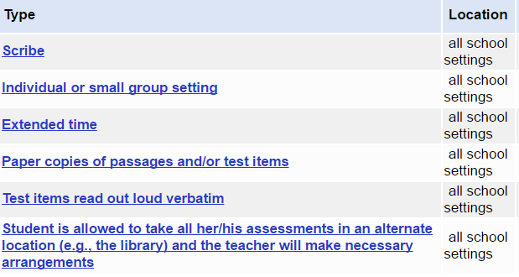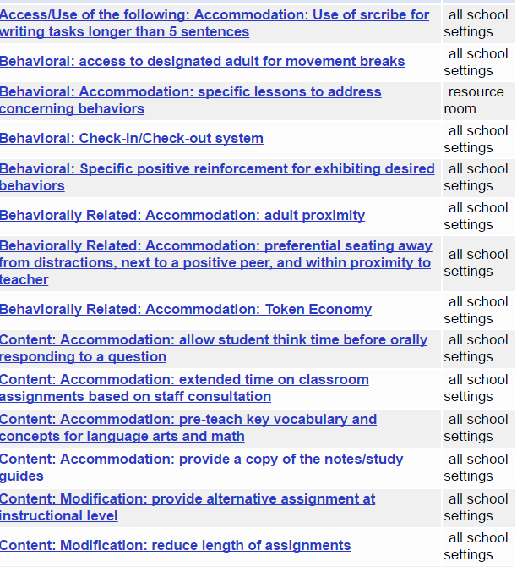

Testing

Whatever the team decides—this student took the smarter-balance basic

The team met for (student) annual IEp meeting to discuss areas of growth, areas of concern, current education program, and least restrictive environment. (student) IEP was set to expire. The team was in agreement of the proposed changes to the plan, no options were considered or rejected. The team used: progress monitoring data, informal and formal observation, general education teacher feedback, behavior data, STAR data, student feedback and work samples, parent input, and BIP data for a basis of action.

Prior Notice