Directions

@Teacherdresscode  
www.theteacherdresscode.com

1. Download the following fonts: [Defying Gravity](https://www.teacherspayteachers.com/Product/KG-Defying-Gravity-Font-Personal-Use-1197600) & [Always a good time](https://www.teacherspayteachers.com/Product/KG-Always-a-Good-Time-Font-Personal-Use-348350)
2. Edit your information
3. To add pictures, right click the image area and click “change picture”
4. Print & laminate!

**Example**

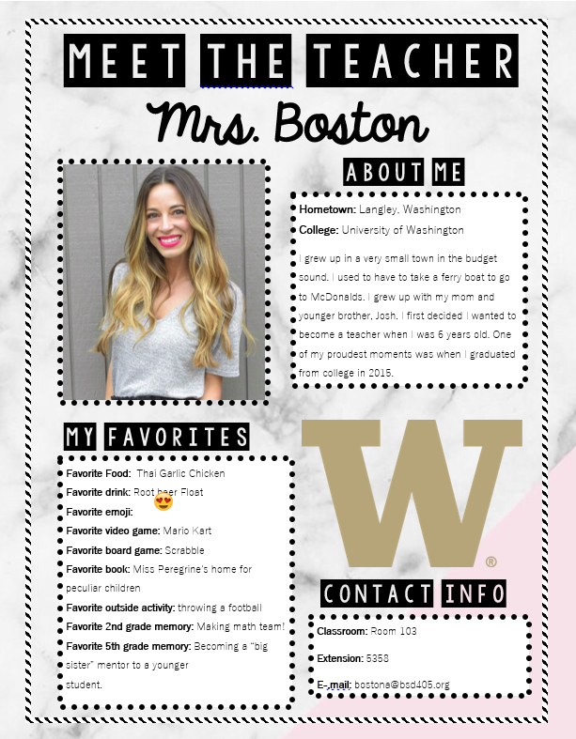



**Classroom:**

**Classroom Extension:**

**E-mail:**

**Hometown:   
College:**

About me blurb!

About me

Contact info

Name

Insert College mascot  
here

**Favorite Food:   
Favorite Drink:   
Favorite Emoji:   
Favorite Video Game:   
Favorite Board Game:   
Favorite Book:   
Favorite Outside Activity:   
Favorite (grade level you teach) Grade Memory:**

**Favorite Subject in ____ grade:**

Insert favorite teacher photo  
here

Meet The Teacher

My Favorites